Essential AI and Prompt Engineering (PYP003)
Muhammad Mohsin Butt
Preparatory Computer Science
Preparatory Science and Engineering Program


King Fahd University of Petroleum & Minerals
College of General Studies – Preparatory Year Program
Introduction:

Artificial Intelligence (AI) is at the forefront of rapidly evolving modern technological landscape. Internationally, universities are recognizing the importance of introducing AI at an early stage to prepare students for future careers in technology.
This introductory course provides preparatory year students with foundational knowledge in Artificial Intelligence (AI), Machine Learning (ML), and Deep Learning (DL). Students will explore core AI concepts and get hands-on experience with no code platforms to build AI models. By the end of the course, students will understand key AI concepts, apply basic model training and testing techniques, explore real-world applications of AI, and discover ethical implications of AI.

Pre-requisites: None

Course Objectives:

The course objectives are listed below:
- Introduce fundamental concepts of Artificial Intelligence (AI), Machine Learning (ML), and Deep Learning (DL).
- Equip students with hands-on experience of using AI models and improve problem-solving skills.
- Design effective prompts for Large Language Models (LLMs) and analyze model responses.
- Evaluate ethical and societal implications of AI solutions.

Course Learning Outcomes:
Upon successful completion of this course, the student should be able to:
- Explain the key concepts of Artificial Intelligence (AI), Machine Learning (ML), and Deep Learning (DL).
- Differentiate between supervised, unsupervised, and reinforcement learning techniques.
- Use no-code AI tools for implementing basic AI Models.
- Apply prompt‑engineering techniques to improve LLMs outputs.
- Identify bias, fairness, privacy, and safety concerns in AI solutions.
- Demonstrate discipline, and teamwork in developing and evaluating AI solutions.

Required Material:
- Course material will be provided on the blackboard in the form of Lecture Slides, and Practice Exercises.
- No-code AI tools e.g., Teachable Machine, KNIME Analytics, MATLAB, LLMs, will be used for LAB experiments and projects.
- Lectures / Labs for the course will be conducted face to face on campus. For backup, Blackboard Collaborate Ultra or MS Teams will be used.

Topics Covered:

The course will cover the following topics.
No. | Topics | Contact Hours
1 | Introduction to AI, ML, DL | 03
2 | Data & Problem Formulation for AI (datasets, features, target definitions) | 03
3 | No‑Code AI Platforms & Workflow | 04
4 | Supervised Learning Using No-Code AI tools | 08
5 | Large Language Models & Prompt Engineering | 08
6 | Ethical & Responsible use of AI | 04
 | Total | 30

Assessment Plan:

The course will cover the following topics.
Assessment Task | Proportion of Total Assessment Score
Quizzes (04 Quizzes x 5) | 20%
Project 01 | 30%
Project 02 | 30%
Weekly Exercise | 20%

Teaching Plan:

Week | Date | Lab Topic
1 | Aug 19- 25  (WED-TUES) | Introduction to Artificial Intelligence (AI) and Machine Learning (ML)  - Basics of AI.  - Fundamentals of ML.  - Supervised vs Unsupervised learning.  - Applications.  - Practice Exercise
2 | Aug 26- Sep 1  (WED-TUES) | Introduction to Neural  Networks and Deep Learning  - Neural Networks.  - Deep Learning.  - Introduction to Generative AI and LLMs.  - Practice Exercise
3 | Sep 2-8  (WED-TUES) | Data & Problem Formulation  - Identify dataset from a real-world problem.  - Define features, target  - Practice Exercise.
4 | Sep 9-15  (WED-TUES) | No Code AI Platforms  - Introduction to no code AI platforms  - Practice image classification with google teachable machine.  - Practice Exercise  Quiz 01 (Week 01-02 Material)
5 | Sep 16-22  (WED-TUES) | Supervised Classification  - Basic supervised classification concepts  - Practice Exercise using no code AI platforms.  - Practice Exercise
5 | Wed – Thu Sep 23-24 | National Day Holiday
6 | Sep 27- Oct 1  (SUN-THU) | Supervised Classification  - Training and Testing AI Models.  - Practice Exercise using no code AI platforms.  - Practice Exercise
7 | Oct 4-8  (SUN-THU) | Model Evaluation  - Confusion Matrix  - Evaluation metrics via no code dashboards.  - Practice Exercise  Quiz 02 (Week 03-05 Material)
8 | Oct 11-15  (SUN-THU) | Project 1 Presentation

Week | Date | Lab Topic
9 | Oct 18-19  (SUN-MON) | Introduction to Large Language Models and Generative AI.  - Introduction to Generative AI and LLMs.  - Understand LLM working  - Understand model parameters and tokenization  - Practice Exercise
 | Tue-Wed-Thu  Oct 20 -22 | Midterm Break
10 | Oct 25- 29  (SUN-THU) | October 25-26 (For SUN-MON)  Introduction to Prompt Engineering & Transformers  - Understand transformer architecture  - Basics of Prompt Engineering  - Understanding Web search, Deep research, and knowledge base in LLMs  - Writing basic prompts and checking different responses.  - Practice Exercise. | October 27-29 (For TUE-WED-THU)  Introduction to Large Language Models and Generative AI.  - Introduction to Generative AI and LLMs.  - Understand LLM working  - Understand model parameters and tokenization  - Practice Exercise
11 | Nov 1-Nov 5  (SUN-THU) | November 01-02 (For SUN-MON)  Techniques for Effective Prompt Engineering  - Learn different prompting techniques  - Persona, Task, Context, Format (PTCF) framework.  - Practice Exercise | November 03-05 (For TUE-WED-THU)  Introduction to Prompt Engineering & Transformers  - Understand transformer architecture  - Basics of Prompt Engineering  - Understanding Web search, Deep research, and knowledge base in LLMs  - Writing basic prompts and checking different responses.  - Practice Exercise.

12 | Nov 8-12  (SUN-THU) | November 08-09 (For SUN-MON)  Advance AI tools and Agents  - Custom Chatbots  - Retrieval Augmented Generation (RAG)  - Practice Exercise | November 10-12 (For TUE-WED-THU)  Techniques for Effective Prompt Engineering  - Learn different prompting techniques  - Persona, Task, Context, Format (PTCF) framework.  - Practice Exercise
13 | Nov 15-19  (SUN-THU) | November 15-16 (For SUN-MON)  Ethical and Responsible use of AI  - Responsible use of AI  - Practice Exercise  Quiz 03 (Week 09 – 10 Material) | November 17-19 (For SUN-MON)  Advance AI tools and Agents  - Custom Chatbots  - Retrieval Augmented Generation (RAG)  - Practice Exercise  Quiz 03 (Week 09 – 10 Material)
 | Sun-Mon  Nov 22-23 | Autumn Break
13 | Nov 24 – 26  (TUE-WED-THU) | Ethical and Responsible use of AI  - Responsible use of AI  - Practice Exercise
14 | Nov 29 – Dec 03  (SUN-THU) | Ethical and Responsible use of AI  - Privacy and Security concerns with AI.  - Domain specific AI case study
15 | Dec 06 – 10  (SUN-THU) | Project 02  Quiz 04 (Week 11 – 14 Material)

Course Policies, Rules and Regulations for Online Classes and Assessments
- Project Groups
  - Students are required to form groups of 3-4 students for the presentations and project.
  - Students can change groups during the course if some members of a group leave the university.
  - The group members list should be sent to the instructor by the end of week 03. If you cannot find the group members, the instructor will randomly create groups in week 04.
- Hardware / Software Requirements
  - Make sure you have all the learning tools ready:
    - Reliable PC/desktop or Laptop (updated software and hardware)
    - KNIME Analytics
    - Desktop versions of LLMs i.e., ChatGPT, Claude, Gemini, NotebookLM etc.
- Course Website & Participation
  - Students are required to periodically check the blackboard and download course material as needed. All resources will be posted on the blackboard as well.
https://blackboard.kfupm.edu.sa/
- Classes and Attendance Policy:
  - Classes will be conducted on campus face to face.
  - Anyone who joins the class during the first 5 - 10 minutes will be marked LATE. A total of 3 late attendances is equivalent to one unexcused absence.
  - Anyone who joins the classroom after 10 minutes will be marked absent.
  - Students are required to stay active during the class. This will be ensured by having interactive questions during the class time. If the student fails to respond when asked anytime during the class, he will be marked absent.
- DN Rules:
  - A student will be given a DN grade if he/she reaches Three (3) unexcused absences.
  - A student will be given a DN grade if he/she reaches a total of Four (5) absences (both excused and unexcused).
  - To avoid being considered absent, an official excuse must be shown no later than one week after returning to class.
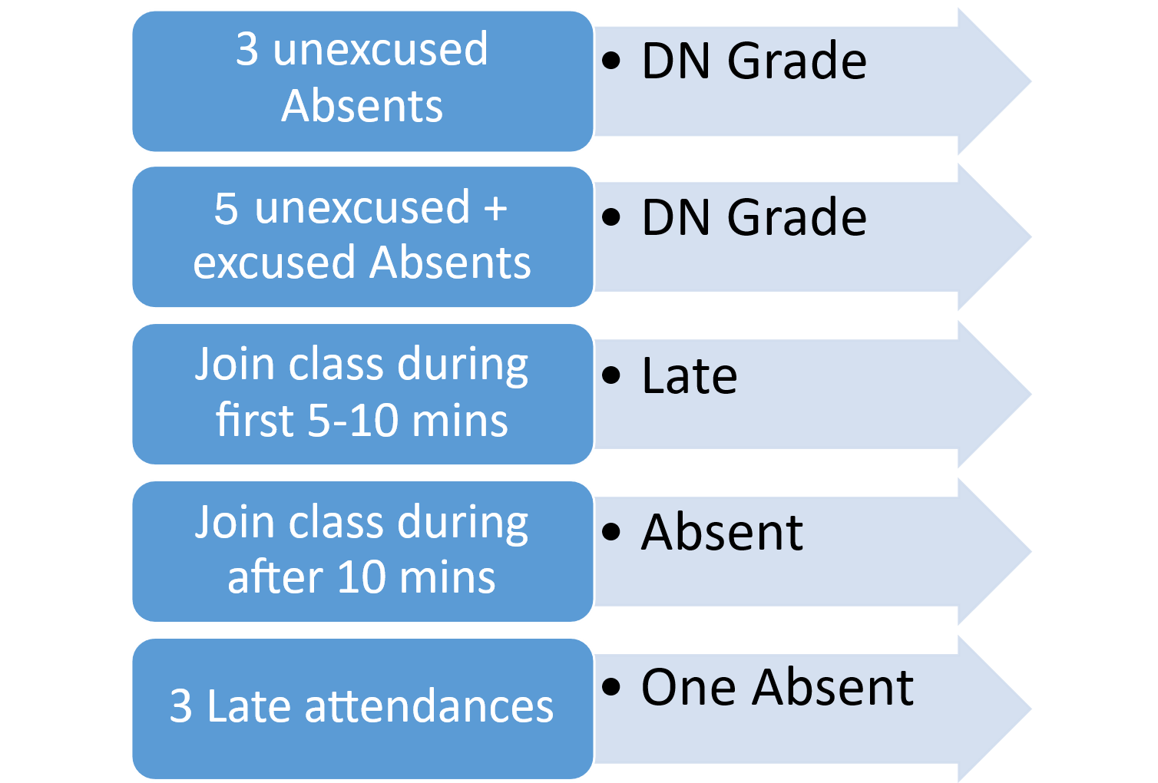
- Quizzes
  - Quizzes will be MCQ based and conducted on the blackboard website.
  - Students must complete the Quiz in the allotted time. No extra time will be given.
- Project
  - Results for the project will be made available in one week.
- Re-checking policy
  - If you have a complaint about any of your marks, discuss it with the instructor no later than one week after distribution of marks. Only legitimate concerns on grading should be discussed
- Office Hours:
  - Students are encouraged to join office hours to clarify any part of the course material.
- Academic honesty:
  - Students are expected to abide by all the university regulations on academic honesty. Cheating will be reported to the Department Chairman and will be severely penalized. Although collaboration and sharing knowledge is highly encouraged, copying others’ work without proper citation, either in part or full, is considered plagiarism. Whenever in doubt, review the university guidelines or consult the instructor.
- Cheating in any form will result in an F grade.
- Courtesy:
  - Students are expected to be courteous toward the instructor and their classmates throughout the duration of this course. To contact your instructor, please use KFUPM EMAIL. When necessary to send an email through the university email system, please indicate PYP003-261 in the "Subject" field of your email and mention the section number, e.g., “PYP003-261-Section XX- Question about Exercise 1”.

