|  |  |
| --- | --- |
|  | PYP002: Introduction to Digital Technologies |
|  |  |
|  | Course Coordinator: Muhammad Mohsin Butt  Syllabus: First Semester 2024-2025 (241)  Preparatory Science and Engineering Program |

**King Fahd University of Petroleum & Minerals**

College of General Studies – Preparatory Year Program

**Instructor Information**

|  |  |  |
| --- | --- | --- |
| **Teacher Name**  **Email** | **Muhammad Mohsin Butt**  [**mohsinbutt@kfupm.edu.sa**](mailto:mohsinbutt@kfupm.edu.sa) | |
| **Room #** | **Building 57 Room 424** | |
| **Office Hour Teacher** |  | |
| **Help Session** |  | |
| **Course Coordinator** | **Muhammad Mohsin Butt** | |
| Location  Office Phone  Email | **Building # 57, Room 424**  **3161**  **mohsinbutt@kfupm.edu.sa** |

**Course Catalog Description:**

Introduction to computing systems and modern digital technologies. Introduction to computer networks, cybersecurity, and digital ethics. Introduction to algorithms and python programming language. Develop an understanding of blockchain networks, internet of things, artificial intelligence, machine learning, virtual/augmented reality and data science.

**Pre-requisites:** None

**Course Objectives:**

Course objectives are

1. **Introduce** to the students the basic principles, terms and concepts of computer systems and networks.
2. Guide students to **formulate the algorithmic solution** to a problem and implement it in python programming language.
3. Help students to gain **basic understanding** and working principles of modern digital technologies.

**Course Learning Outcomes:**

Upon successful completion of this course, the student should be able to:

1. Identify basic elements and recognize the key concepts of computer systems and modern digital technologies.
2. Describe the key concepts related to computer networks, internet, and cybersecurity.
3. Recognize and describe the modern digital technologies that include blockchain networks, internet of things, artificial intelligence, machine learning, virtual/augmented reality, and data science.
4. Formulate the algorithmic solution to a problem using concepts such as iteration and conditional operations.
5. Write a program as a simple algorithmic solution using python.
6. Implement and train basic machine learning models and evaluate their performance using python.

**Required Material:**

* Course material will be provided on the blackboard in the form of LAB Manual, Practice Questions and Lecture Slides.
* Lectures / Labs for the course will be conducted face to face on campus. For backup, Blackboard Collaborate Ultra or MS Teams will be used.
* It is recommended for the students to install python on their personal computing devices.
* A working google account is required to access google colab website for interactive python sessions during the LABs. [https:/colab.research.google.com/](https://colab.research.google.com/)

**Topics Covered:**

|  |
| --- |
| **PART 01**   1. Introduction to Computer Hardware and Software 2. Introduction to Digital Technologies |
| **PART 02**   1. Introduction to Computer Network, Cybersecurity and Blockchain Networks 2. Basics of Internet of Things, Virtual and Augmented Reality |
| **PART 03**   1. Introduction to algorithms and python programming 2. Variables manipulation 3. Selection, and repetition structures in python |
| **PART 04**   1. Introduction to Data Science 2. Data Visualization and Analysis 3. Introduction to Artificial Intelligence, Machine Learning, Deep Learning 4. Practical Examples using python |

**Assessment Plan:**

|  |  |
| --- | --- |
| **Presentations**   1. **Presentation from Part 01** 2. **Presentation from Part 02** | **30 %** |
| **Project**   1. **Project based on list provided (Machine Learning).** | **30 %** |
| **Class Participation**   1. **Different practical exercises conducted during class time.** | **20 %** |
| **4 Quizzes (5 x 4)** | **20 %** |
| **Total** | **100%** |

# Material for Quizzes

1. Quiz 01
   1. Introduction to computer hardware and software
2. Quiz 02:
   1. Computer Networks and Cybersecurity and blockchain networks
   2. IoT and AR/VR
3. Quiz 03
   1. Algorithms and Python programming
   2. Variables and Lists
   3. If-else conditions
4. Quiz 04
   1. Repetitions in Python
   2. File handling and data analysis (pandas and matplotlib)
   3. Basic ML questions

**Teaching Plan/Course Outline:**

| **Week** | **Start** | **End** | **Lab Topic** |
| --- | --- | --- | --- |
| **1** | **25-Aug-2024** | **31-Aug-2024** | Computer Systems, Components, and their Functions.   * Basics of computer Hardware * Working of a processor (Instruction Cycle) * Computer Memory |
| **2** | **1-Sep-2024** | **7-Sep-2024** | Computer Software, Operating Systems, Introduction to Digital Technologies   * Introduction to computer software and data representation * Hardware / Software interaction * Introduction to operating systems * Overview of Digital Technologies |
| **3** | **8-Sep-2024** | **14-Sep-2024** | Introduction to Computer Networks   * Basics of Computer Networks * Working of router * Communication protocols * Information transfer on internet (TCP/IP protocol) |
| **4** | **15-Sep-2024** | **21-Sep-2024** | Introduction to Cybersecurity and Blockchain Networks   * Basics of cybersecurity * Cryptography * Data encryption * Hashing * Public / Private Key encryption * Digital Ethics   Blockchain Networks   * Blockchain networks * Proof of Work algorithm (Demo) * Blockchain exercise   **Quiz 01\*\*\*** |
| **5** | **24-Sep-2024** | **28-Sep-2024** | Blockchain Networks (cont’d)  Internet of Things and Augmented/Virtual Reality   * Introduction to internet of things * Main components of IoT * Introduction to AR/VR |
| **6** | **29-Sep-2024** | **5-Oct-2024** | Python Programming   * Introduction to algorithms and python programming * Working with variables and list * Arithmetic and Logical operators * Practice Exercises |
| **7** | **6-Oct-2024** | **12-Oct-2024** | **Presentation 01**   * **Week 01-02 topics** * **Students form groups.** * **Two / Three students in each group** * **All students involved in presentation (Equal distribution of slides)** * **Questions/comments from all the group members** |
| **8** | **13-Oct-2024** | **19-Oct-2024** | Python Programming   * Working with Selection/conditional statements in python * Elif * Introduction to repetition / loops * Range function * Practice Exercises |
| **9** | **20-Oct-2024** | **26-Oct-2024** | Python Programming   * Working with repetition/loop statements in python * For loop * While loop * List comprehension * Practice Exercises   **Quiz 02\*\*\*** |
| **10** | **27-Oct-2024** | **2-Nov-2024** | **Presentation 02**   * **Week 03-07 topics** * **Students continue with the same group.** * **All students involved in presentation (Equal distribution of slides)** * **Questions/comments from all the group members** |
| **11** | **3-Nov-2024** | **9-Nov-2024** | Introduction to AI / Machine Learning and Deep Learning   * Introduction to AI, Machine Learning and Deep Learning * Supervised machine learning * Applications * File reading and plotting data in python.   **Quiz 03\*\*\*** |
| **Midterm Break** | | | |
| **12** | **17-Nov-2024** | **23-Nov-2024** | Introduction to AI / Machine Learning and Deep Learning   * Machine Learning explained. * Data classification example in Python * Explain data analysis functions of pandas. * Introduce Confusion matrix / Evaluation matrix. * Practice Exercise |
| **13** | **24-Nov-2024** | **30-Nov-2024** | Introduction to Data Science   * Basics of Data Science * Learning and Analyzing Data * Practice Exercise |
| **14** | **1-Dec-2024** | **7-Dec-2024** | **Project Presentation and submission (with code/report)**   * **Week 03-13 topics** * **Students continue with the same group.** * **All students involved in presentation (Equal distribution of slides)** * **Code demo and Questions/comments from all the group members** |
| **15** | **8-Dec-2024** | **17-Dec-2024** | **Project Presentation and submission (with code/report)**   * **Week 03-13 topics** * **Students continue with the same group.** * **All students involved in presentation (Equal distribution of slides)** * **Code demo and Questions/comments from all the group members**   **Quiz 04\*\*\*** |

**Four** unexcused labs will result in a **DN grade without prior warning**.

*** Date and Time of Quizzes and presentations are tentative and depend on PYP council approval.

**Presentation Evaluation Rubrics**

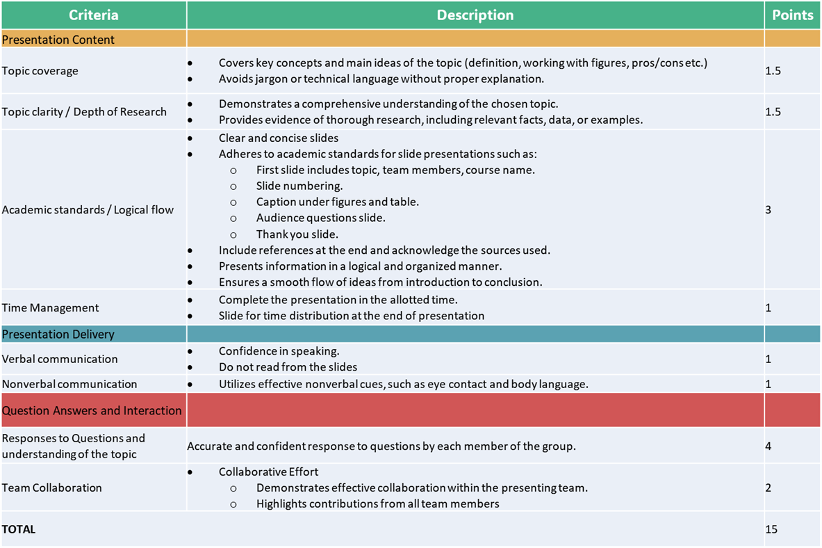

**Project Evaluation Rubrics**





**Course Policies, Rules and Regulations for Online Classes and Assessments**

* ***Project Groups***
  + Students are required to form groups of 2-3 students for the presentations and project.
  + Students can change groups during the course if some members of a group leave the university.
  + The group members list should be sent to the instructor by the end of week 03. If you cannot find the group members, the instructor will randomly create groups in week 04.
* ***Hardware / Software Requirements***
  + Make sure you have all the learning tools ready:
    - Reliable PC/desktop or Laptop (updated software and hardware)
  + Python should be installed on your system with English Language for practicing the exercises at home.
* ***Course Website & Participation***
  + Students are required to periodically check the blackboard and download course material as needed. All resources will be posted through the blackboard as well.

[https://blackboard.kfupm.edu.sa/](https://blackboard.kfupm.edu.sa)

* ***Classes and Attendance Policy:***
  + Classes will be conducted on campus face to face.
  + Anyone who joins the class during the **first 5 - 10 minutes** will be marked **LATE**. A total of **3 late attendances** is equivalent to **one unexcused absence**.
  + Anyone who joins the classroom **after 10 minutes** will be marked **absent**.
  + Students are required to stay active during the class. This will be ensured by having interactive questions during the class time. If the student fails to respond when asked anytime during the class, he will be marked absent.
* ***DN Rules:***
  + A student will be awarded a DN grade if he/she reaches **Four (4)** unexcused absences.
  + A student will be awarded a DN grade if he/she reaches a total of **Five (5)** absences (both excused and unexcused).
  + To avoid being considered as absent, an **official excuse** must be shown **no later than one week after returning to class**.

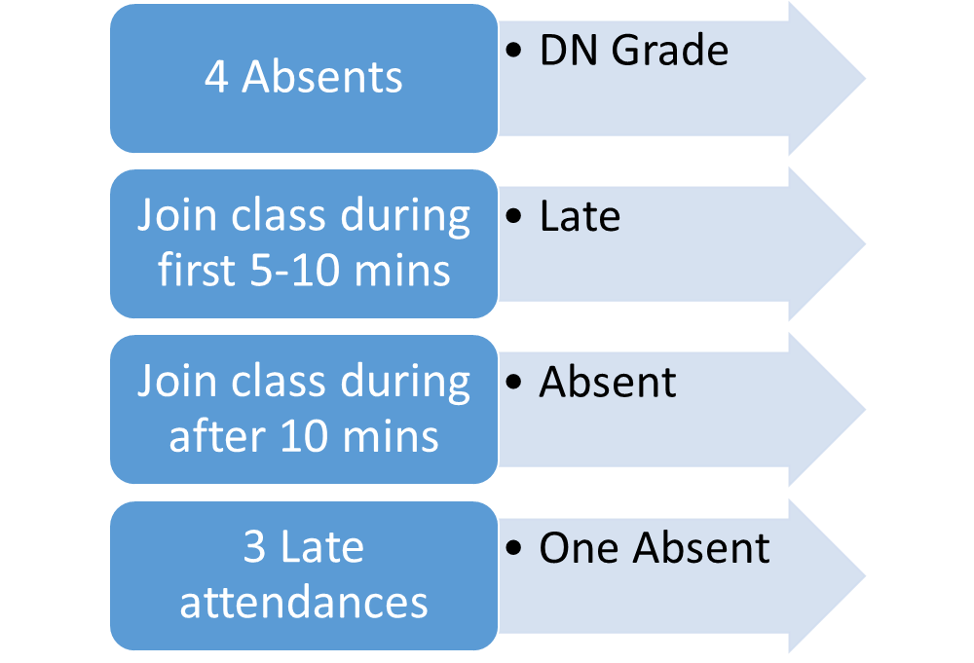

* ***Quizzes***
  + Quizzes will be MCQ based and conducted on the **blackboard** website.
  + Students must complete the Quiz in the allotted time. No extra time will be given.
* ***Project***
  + Results for the project will be made available in one week.
* ***Re-checking policy***
  + If you have a complaint about any of your marks, discuss it with the instructor **no later than one week** after distribution of marks. Only legitimate concerns on grading should be discussed
* ***Office Hours***:
  + Students are encouraged to join office hours to clarify any part of the course material.
* ***Academic honesty***:
  + Students are expected to abide by all the university regulations on academic honesty. Cheating will be reported to the Department Chairman and will be severely penalized. Although collaboration and sharing knowledge is highly encouraged, copying others’ work without proper citation, either in part or full, is considered plagiarism. Whenever in doubt, review the university guidelines or consult the instructor.
* **Cheating in any form will result in an F grade.**
* ***Courtesy***:
  + Students are expected to be courteous toward the instructor and their classmates throughout the duration of this course. To contact your instructor, please use KFUPM EMAIL. When necessary to send an email through the university email system, please indicate PYP002-241 in the "Subject" field of your email and mention the section number, e.g., “PYP002-241-Section XX- Question about Exercise 1”.